EXP NO:5 DATE:27/08/2024
DESIGN A PROGRAM USING NAÏVE BAYSION CLASSIFICATION FOR THE SAMPLE DATASET
AIM:
To design a program using naïve baysion classification for the sample dataset.
ALGORITHM:
Step 1: Set prior probabilities: p_cancer and p_no_cancer.
Step 2: Define conditional probabilities for symptoms given cancer status
Step 3:Calculate likelihoods for symptoms..
Step 4: Apply Bayes’ theorem to find posterior probabilities.
Step 5: Predict the class with the higher posterior probability.

ENVIRONMENT:
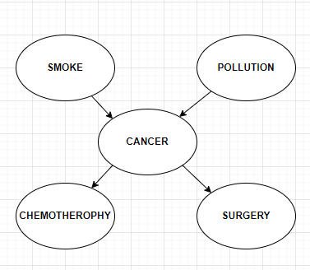

DATASET:
CANCER
P[ Cancer=1] | 0.4
P[Cancer=0] | 0.6

POLLUTION
 | P[ pollution=1] | P[pollution=0]
P[ Cancer=1] | 0.6 | 0.4
P[Cancer=0] | 0.3 | 0.7

SMOKE
 | P[ smoke=1] | P[smoke=0]
P[ Cancer=1] | 0.7 | 0.3
P[Cancer=0] | 0.4 | 0.6

CODE:

# Define prior probabilities
p_cancer = 0.4 # P(Cancer=1)
p_no_cancer = 1 - p_cancer # P(Cancer=0)
# Define conditional probabilities
# P(Smoke | Cancer) and P(Pollution | Cancer)
p_smoke_given_cancer = [0.3, 0.7] # P(Smoke=0 | Cancer=1) and P(Smoke=1 | Cancer=1)
p_smoke_given_no_cancer = [0.6, 0.4] # P(Smoke=0 | Cancer=0) and P(Smoke=1 | Cancer=0)

p_pollution_given_cancer = [0.4, 0.6] # P(Pollution=0 | Cancer=1) and P(Pollution=1 | Cancer=1)
p_pollution_given_no_cancer = [0.7, 0.3] # P(Pollution=0 | Cancer=0) and P(Pollution=1 | Cancer=0)

# Function to predict whether a person has Cancer given Smoke and Pollution
def predict_cancer(smoke, pollution):
# Compute P(Smoke, Pollution | Cancer) and P(Smoke, Pollution | ~Cancer)
p_features_given_cancer = p_smoke_given_cancer[smoke] * p_pollution_given_cancer[pollution]
p_features_given_no_cancer = p_smoke_given_no_cancer[smoke] * p_pollution_given_no_cancer[pollution]

# Compute P(Cancer | Smoke, Pollution) and P(No Cancer | Smoke, Pollution)
p_cancer_given_features = (p_features_given_cancer * p_cancer) / (
p_features_given_cancer * p_cancer + p_features_given_no_cancer * p_no_cancer
)
p_no_cancer_given_features = (p_features_given_no_cancer * p_no_cancer) / (
p_features_given_cancer * p_cancer + p_features_given_no_cancer * p_no_cancer
)

# Determine the predicted class
if p_cancer_given_features > p_no_cancer_given_features:
prediction = "Cancer"
else:
prediction = "No Cancer"
return prediction, p_cancer_given_features, p_no_cancer_given_features

# Test with multiple inputs
inputs = [
(0, 0), # Smoke=0, Pollution=0
(0, 1), # Smoke=0, Pollution=1
(1, 0), # Smoke=1, Pollution=0
(1, 1) # Smoke=1, Pollution=1]
for smoke, pollution in inputs:
prediction, p_cancer_given_features, p_no_cancer_given_features = predict_cancer(smoke, pollution)
print(f"Input: Smoke={smoke}, Pollution={pollution}")
print(f"Prediction: {prediction}")
print(f"Probability of Cancer: {p_cancer_given_features:.2f}")
print(f"Probability of No Cancer: {p_no_cancer_given_features:.2f}")
print()

OUTPUT:

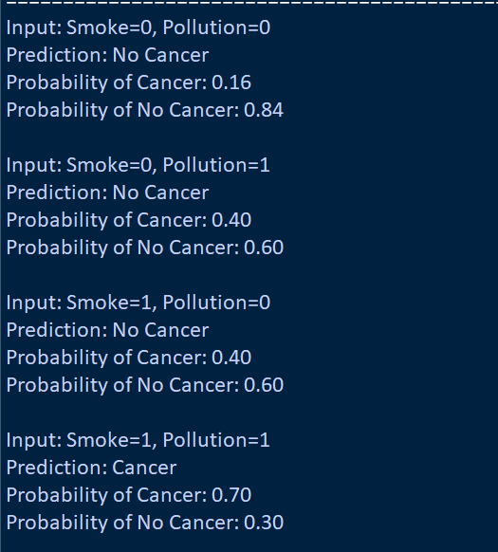

OBSERVATION (20)
RECORD (5)
TOTAL (25)
SIGNATURE

RESULT:
Thus the given naïve baysion classification for the sample dataset is found and the output is verified.

